Employee Sentimental Analysis

Methodology Overview

Data Loading & Inspection:

Preprocessing & Cleaning:
A custom clean_msg() function was used to clean message text. Cleaning steps included:
- Lowercasing text.

- Removing URLs, mentions, hashtags.

- Removing emojis and non-ASCII characters.

- Removing numbers, symbols, AM/PM and extra spaces.

Sentiment Extraction:

Used TextBlob and BERT to compute:

Polarity (−1 = very negative, +1 = very positive)

A custom segmentation function classifies each message as Positive,Neutral,Negative

Time-Based Aggregation:

Added year_month to track monthly sentiment
Pivot tables were used to compute monthly average sentiment per employee

EDA & Visualization:

Heatmaps for detecting monthly sentiment patterns.

Bar charts for overall monthly sentiment trends.

Correlation matrices for numeric feature relationships

Employee Ranking:
For each monthwe found the top 3 positive employees and the bottom 3 negative employees

Flight Risk Analysis:
Based on rolling 30 day negative message windows.

Predictive Modelling Setup:
Created numeric features such as ,Message length,word count and Monthly aggregated metrics

Findings from EDA

Monthly Trends

- Some months show noticeably more negative or positive sentiment.

- The heatmap revealed employees with consistently high or consistently low sentiment.

Message Behavior Insights

- The message lengths and word counts do not strongly correlate with polarity

- Frequency of messages does neither strongly influence sentiment scores

Overall Observations

- Sentiment fluctuations vary significantly between employees.

- Text features alone are insufficient to strongly predict sentiment polarity

Key Findings From EDA

Monthly Trends

Some months show noticeably more negative or positive sentiment.

The heatmap revealed that the employees monthly avg polarity through the months and mostly the avg sentiment has been neutral and positive but there are months with avg negative sentiment too.

Message Behavior Insights

The message lengths and word counts do not strongly correlate with polarity.

Frequency of messages does not strongly influence sentiment scores.

Overall Observations

- Sentiment fluctuations vary significantly between employees.

- Text features alone are insufficient to strongly predict sentiment polarity.

Employee Scoring & Ranking Process

Logic behind the ranking process

Sort each employee by average polarity using our pivot table

Select the top 3 (Top Positive Employees) and the bottom 3 (Top Negative Employees)

Insights From Ranking

Each month has clearly identifiable best and worst sentiment contributors.Some employees remain consistently in positive rankings.

Flight Risk Identification

An Employee is flagged risk if they have 4 or more negative message is a 30 day rolling period

Approach
- Filter dataset for negative messages only.
- For each employee sort the messages during a sliding 30 day window check if negative messages cross the threshold of 4 or more negative messages

Outcomes
All 10 Employees were flagged of flight risk
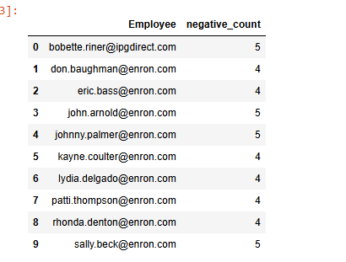
Predictive Model

Feature Engineering

Numeric features created:
Average polarity,Average message length,Average word count,Message frequency

With these numeric features when we did a correlation heatmap we found extremely weak relationship with sentiment polarity and all our numeric features
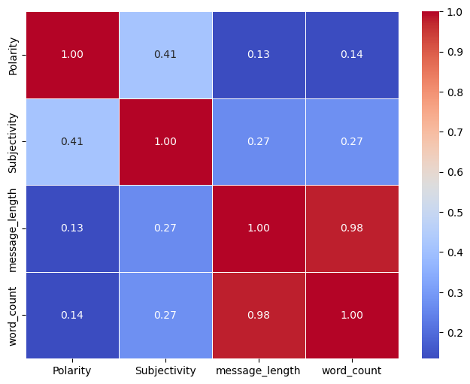

Due to weak correlation among variables, linear regression or text independent models would perform poorly

